Oratorical

Scholarship

An eight to ten-minute oration could earn you a $25,000 scholarship.
For over 80 years, The American Legion has sponsored a speech contest for high school students grades 9 through 12. The Legionnaires of North Carolina award a $2,500 scholarship to the winning student. $7,000 is awarded to the top ﬁve students at the State Contest. The winning North Carolina contestant also receives expenses for themselves and a chaperon to the National Finals in Indianapolis, Indiana in April 2022.

National Awards

2ND PLACE

$22,500
1ST PLACE
$25,000

3RD PLACE

$20,000

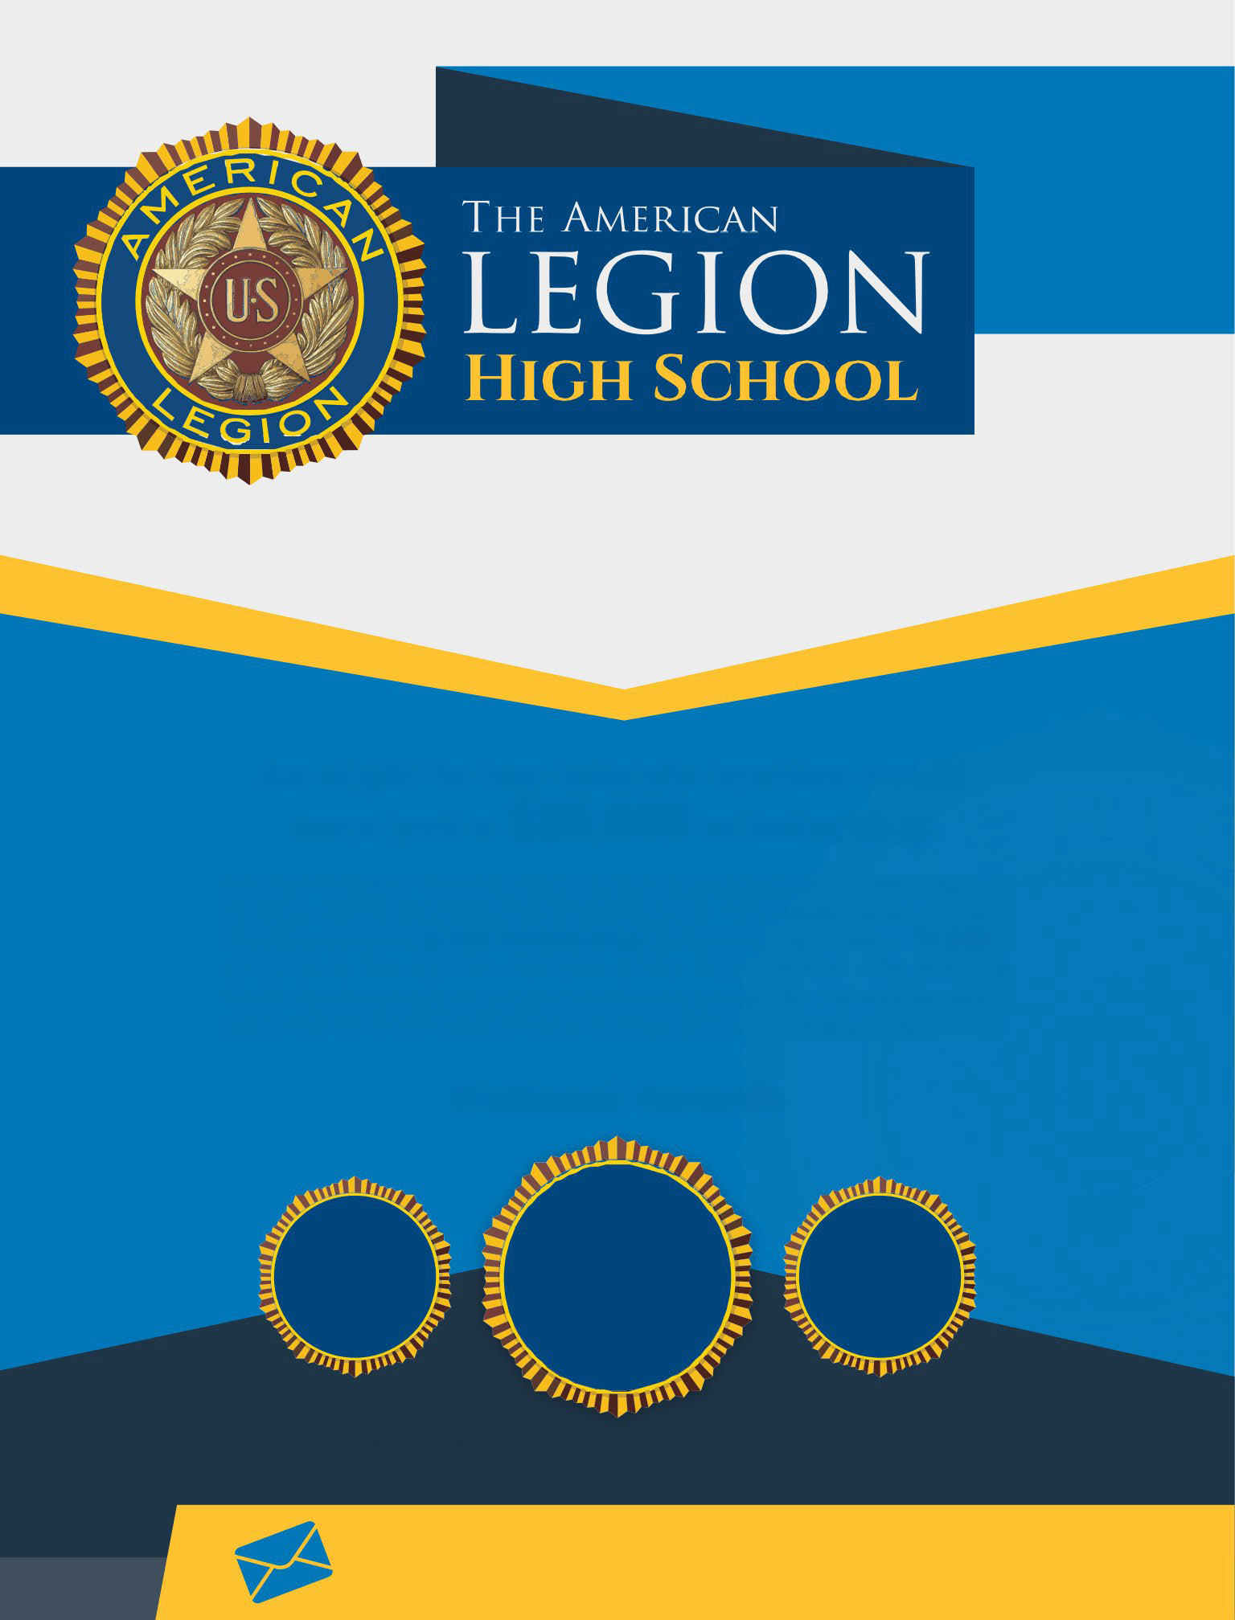

A total of $203,500 is awarded annually by The American Legion.
The American Legion is a non-proﬁt veterans organization that was chartered by Congress in 1919.

To learn more, send an email to
A set of rules and links will be emailed to you.

